Week 12

Q.1). Read a dataset and implement a basic classification model.
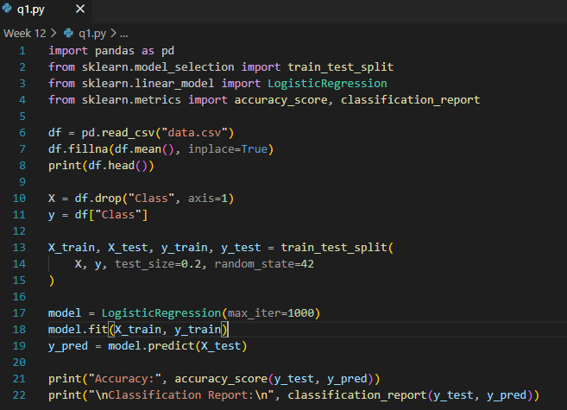
Output
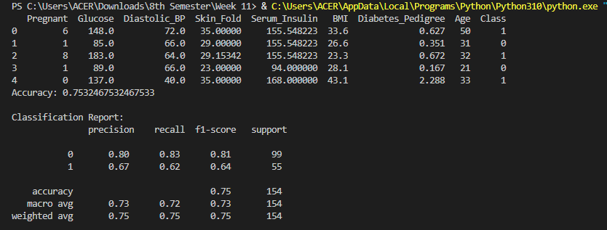

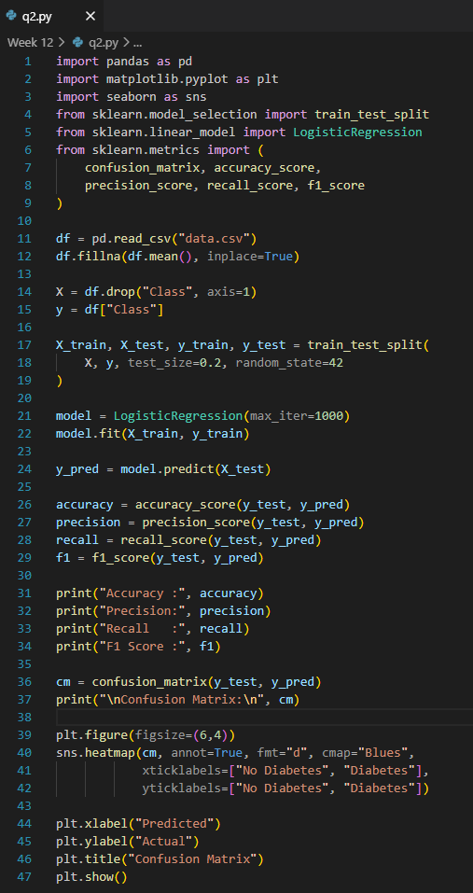
Q.2). Generate and interpret a confusion matrix. Calculate accuracy, precision, recall, and F1 score and visualize classification results.

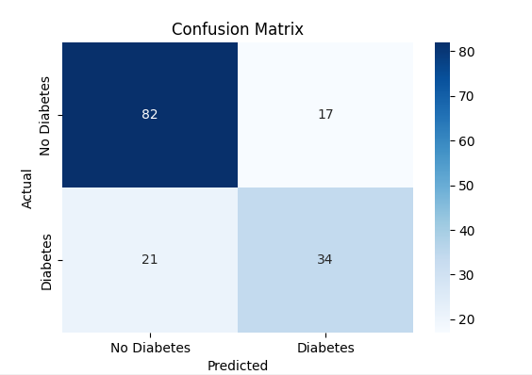
Output
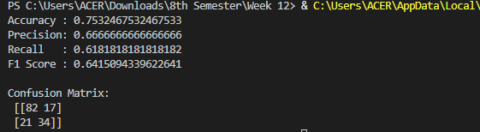
Q.3). Use various classification models and compare them on the same datasets
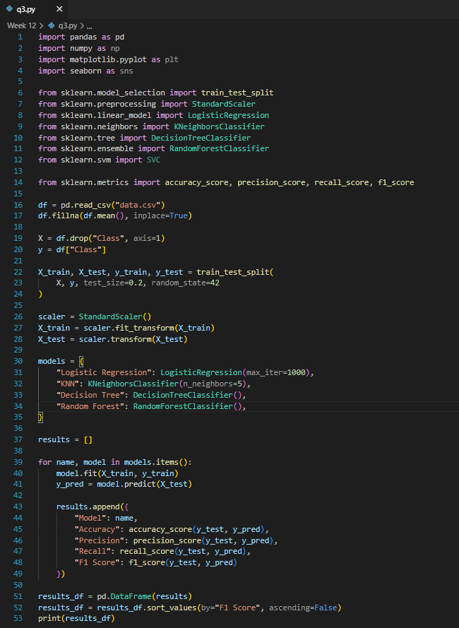
Output
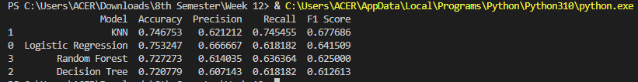

Problems Based on HTML and XML:
Q.4). Create a CD catalog using XML file.
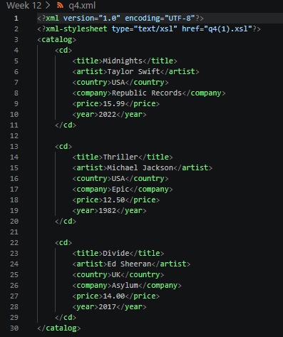
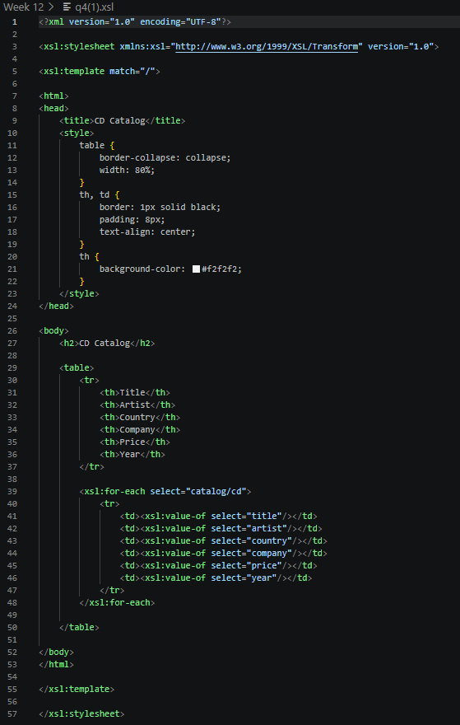
Output
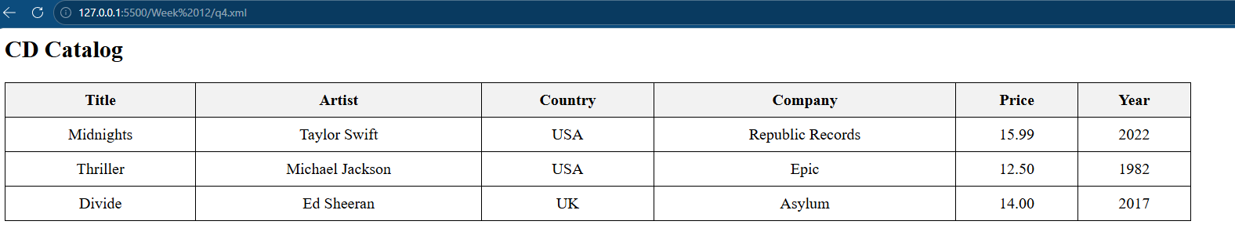
Q.5). Create external style sheet and using the style sheet in XML file.
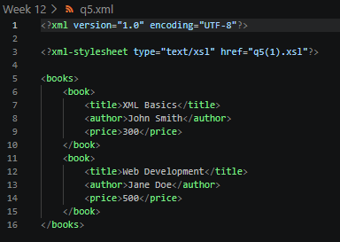
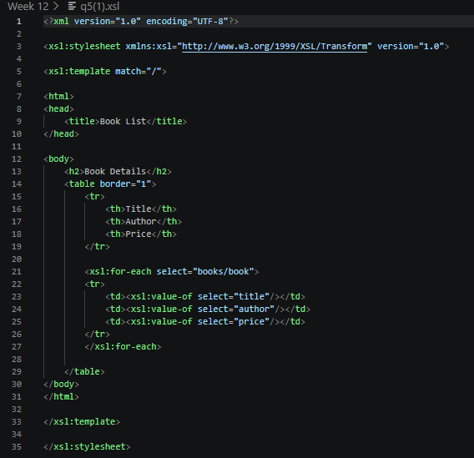
Output
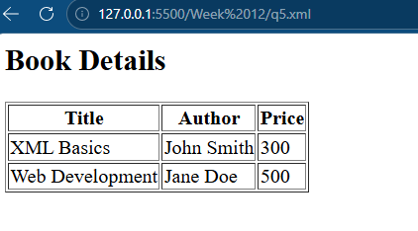
Q.6). Create an XSL style sheet to display the data in the xml using HTML table.
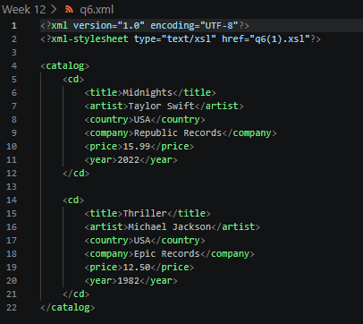
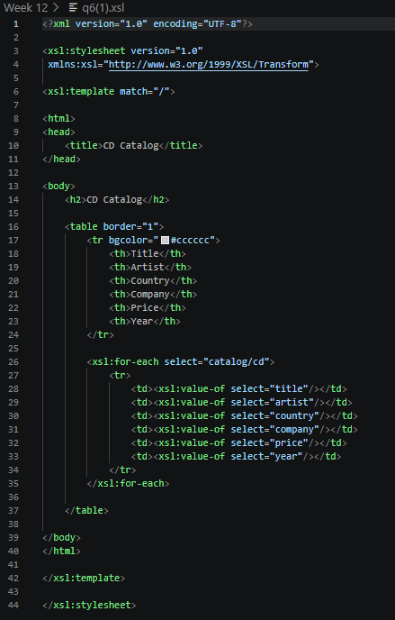
Output
